## **Boulder puzzle outside Skuld’s Temple:**

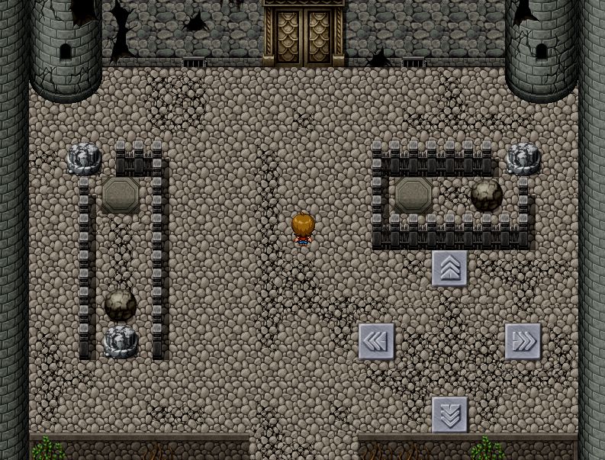

The directional pressure plates on the bottom right controls how the boulders move. The boulders move per block if the player steps on the pressure plate.

How to solve:   
1) Step on the “UP” pressure plate 3 times  
2) Step on the “LEFT” pressure plate 2 times

A textbox will appear telling you that you solved the puzzle and that the gate opened.  
Walk through the gate.

## Skuld’s Temple Interior:

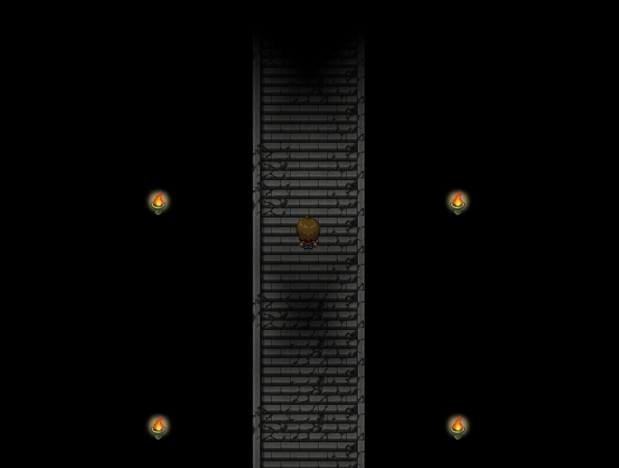

Walk up the stairs until you meet Skuld. It will talk to you. Advance through textboxes. There will be a short cutscene after that.

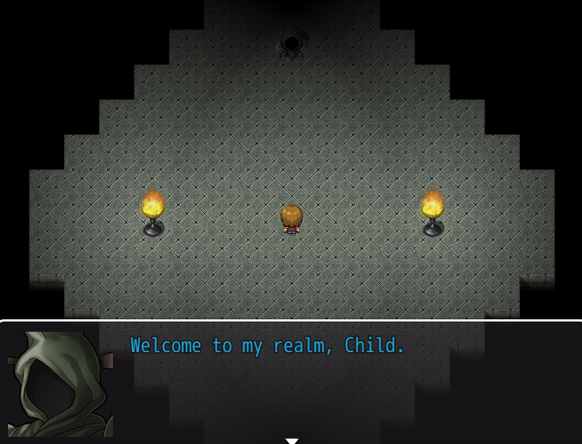

## Town area:

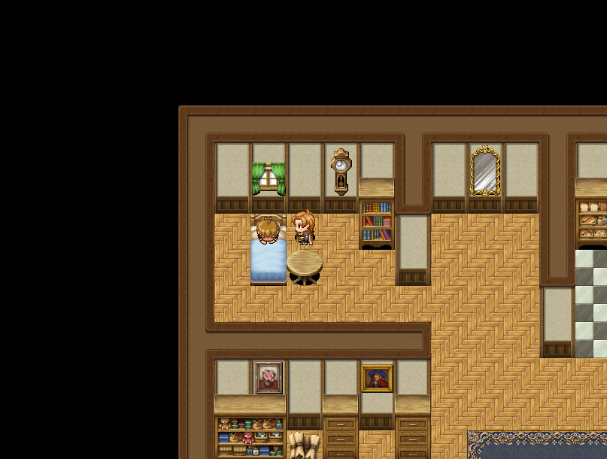

After the short cutscene, you will find yourself in Father’s body with the Son in the bed. You are now controlling Father.

In order to get to the next level, you will have to find a book that details how to cure Ahelioism.

How to solve:  
1) Get out of MC’s house  
2) Go to the library located on the right of the MC’s house and enter the library   
3) Go to the second floor of the library  
4) Interact with the bookshelf in the far top right corner. It is a double bookshelf with different coloured books.

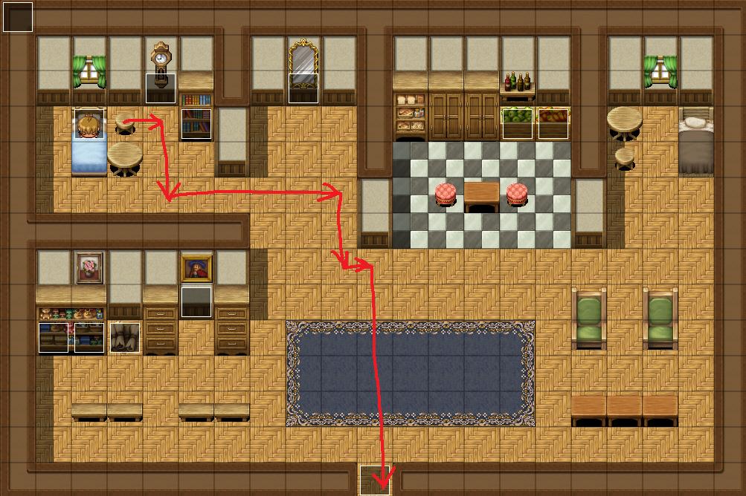

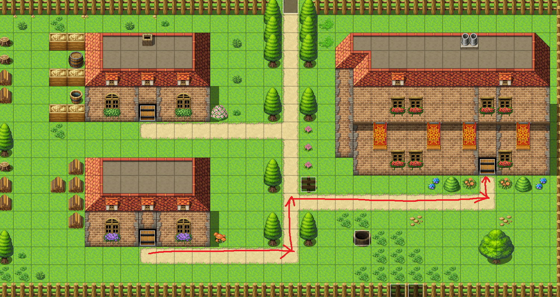

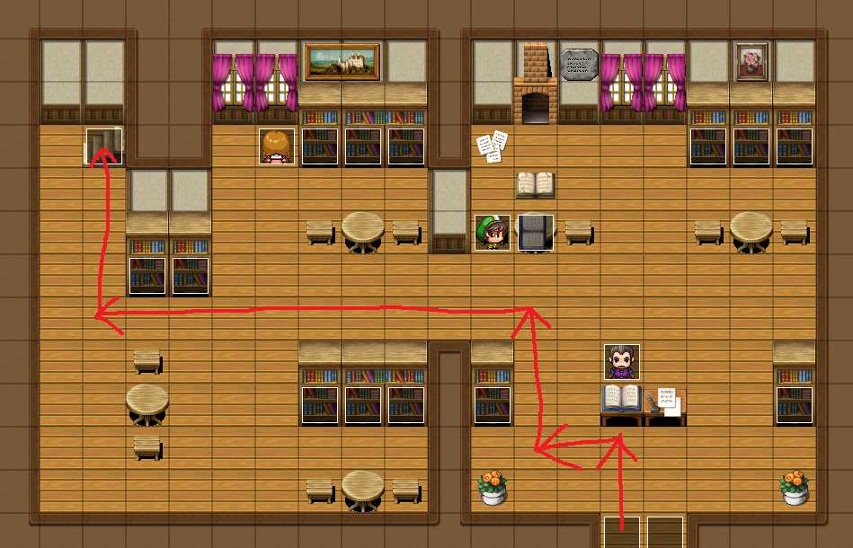

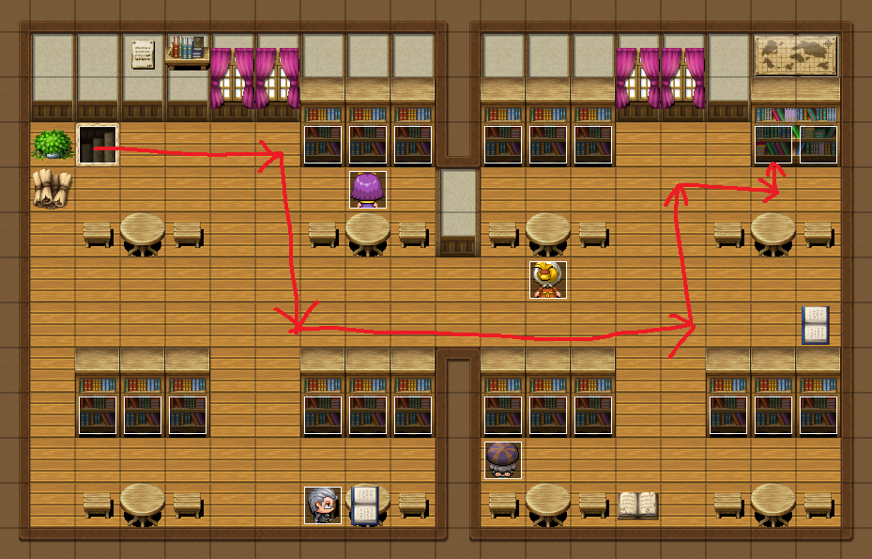

## Burning Library:

Follow these paths to escape the burning library:

2nd floor:  
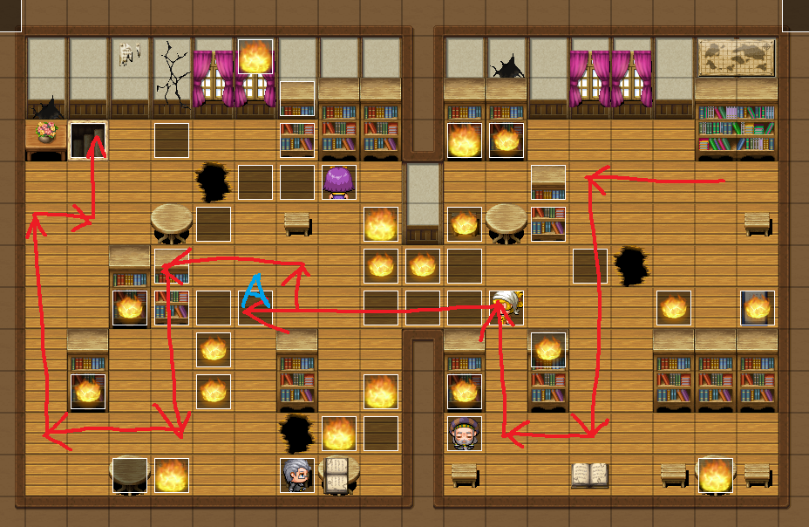  
Note about A:  
You have to walk into the trigger to make the bookshelf fall so that the path will appear.

1st floor:  
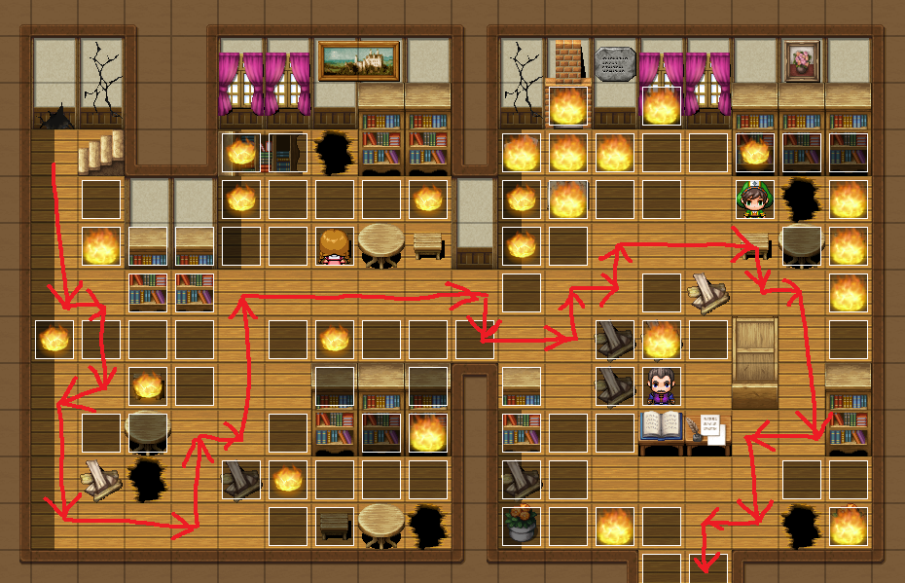

## Grove of Sunwillows:

After the burning library, you will be faced with a cutscene.  
After the cutscene, you will find yourself in the Grove of Sunwillows.

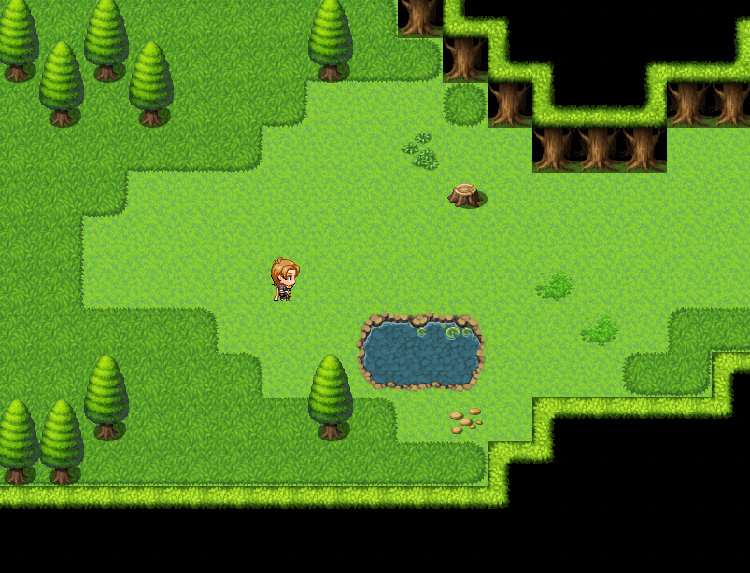

Walk right until the forest guardian talks to you. Advance through the textboxes and keep going right until you enter the Lost Woods.

## Grove of the Sunwillows:

The way to exit the lost woods is to look at the flowers in the center and go to the path where the colour of the flowers match those in the center.

The order is as follows:  
1) White  
2) Pink  
3) Blue  
4) Red

1st Area:

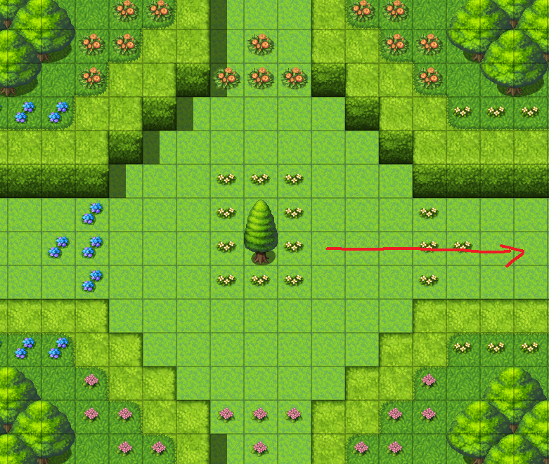

2nd Area:

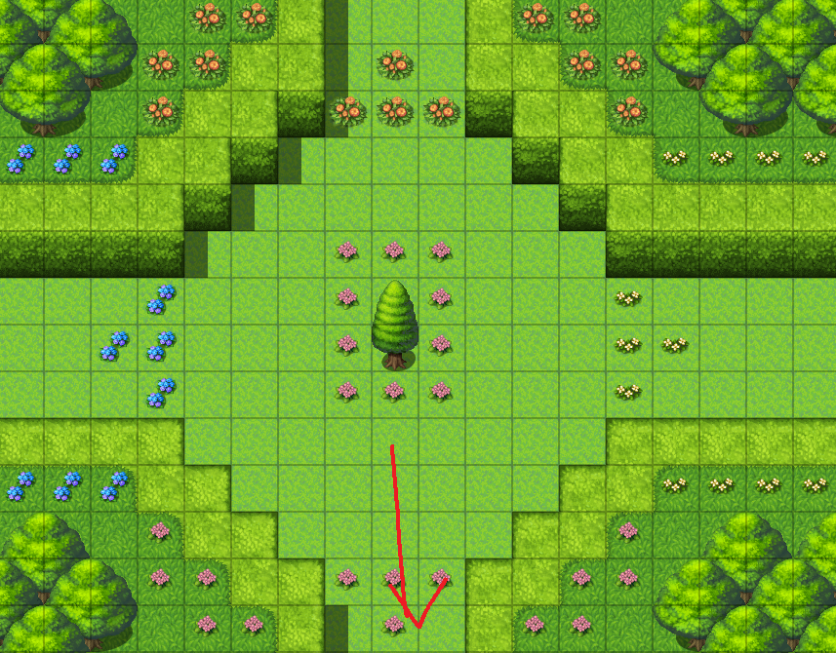

3rd Area:

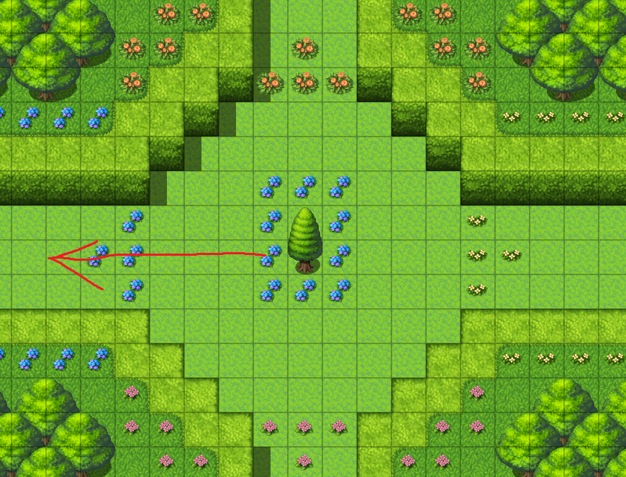

4th Area:

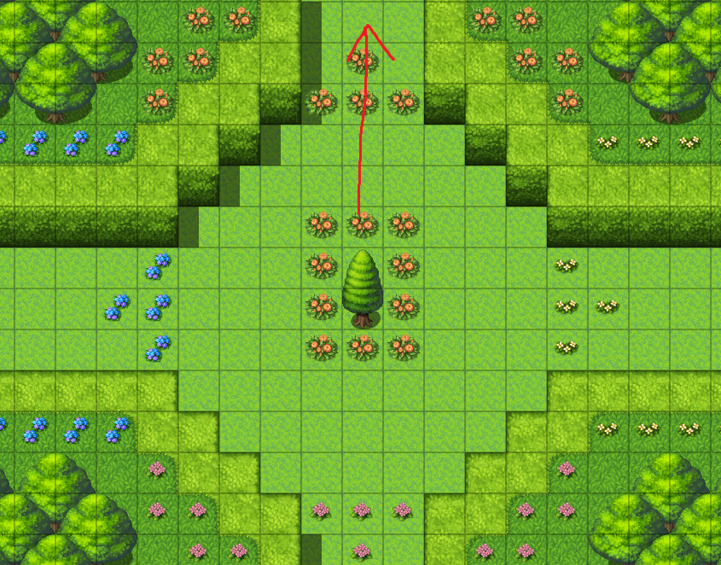

## Inner Grove:

You will enter the Inner Grove once you solve the Lost Woods. The forest guardian will talk to you. Advance through it. You will encounter a boulder puzzle similar to the one outside Skuld’s Temple.

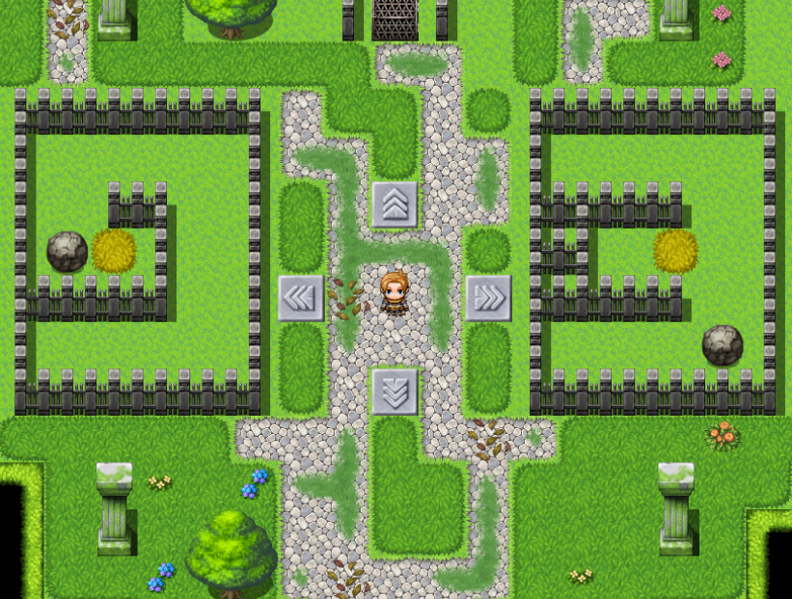

You have to solve this to get to the flower that will cure Ahelioism.

To solve this, follow these steps:  
1) Step on the “RIGHT” pressure plate 1 time.  
2) Step on the “UP” pressure plate 2 times.  
3) Step on the “LEFT” pressure plate 2 times.  
4) Step on the “RIGHT” pressure plate 1 time.

After doing this, a textbox will appear telling you that the gate in unlocked. Walk up and interact with the flower. Advance through the textboxes and a cutscene will appear.

## Stein’s Tower:

After the cutscenes, you will find yourself outside of Stein’s Tower.

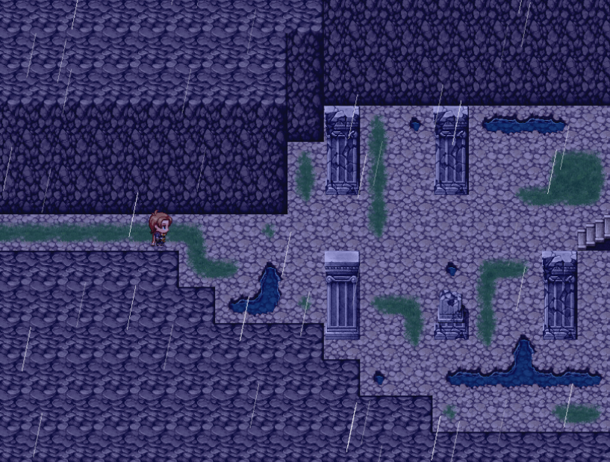

Walk right and advance through the textboxes. A timer will appear and you will have to reach the top where Stein is before the time runs out. There are 3 levels you have to solve before you reach Stein.

Level 1:

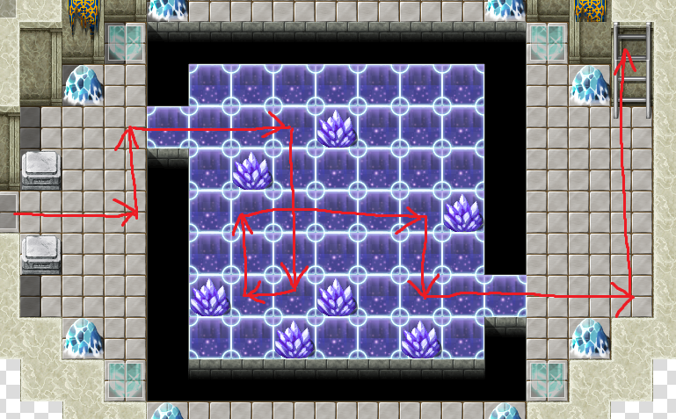

This level is a slide puzzle. The player will slide on the blue tiles until the player hits an obstacle or there is no path to keep sliding on.

To solve it, follow the path in the picture above.

Level 2:

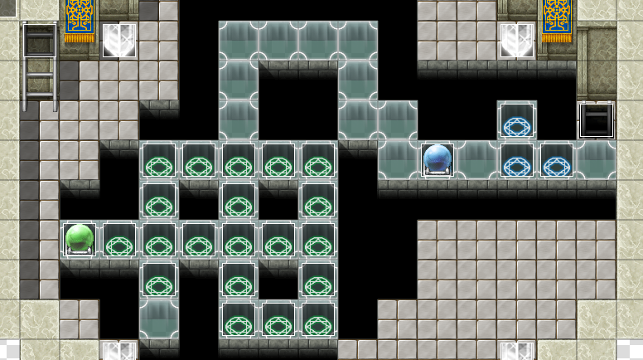

This level is a puzzle where the floor circles will activate/deactivate once you step on it. Activate (make the circles red) to open the orb gates to advance to the next section.  
To solve it, follow this gif:

<https://gfycat.com/gifs/detail/ThirdHarmfulIlladopsis>

After solving level 2, you will enter the third level with Stein. Walk to him and Skuld will interfere and change the level.

Level 3:

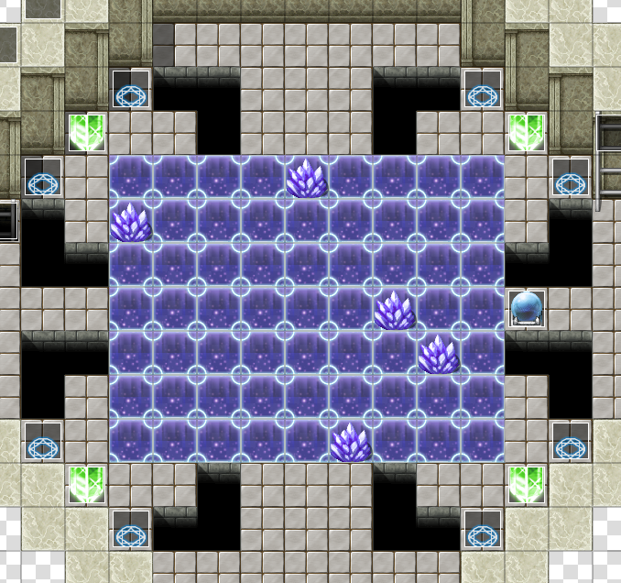

This level is a combination of level 1 and level 2.   
To solve it, follow this gif:

<https://gfycat.com/gifs/detail/RingedWeakAurochs>

After completing this level, you will reach level 4. The longest cutscene will play here until you regain full control in the game at Skuld’s Temple as Son.

## Skuld’s Temple Interior:

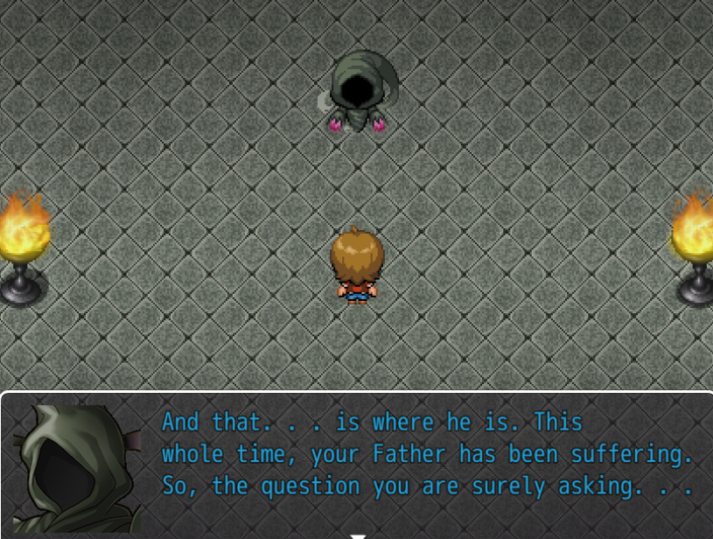

After the cutscene, you will appear in Skuld’s Temple Interior as Son talking to Skuld.

Walk up and past the stairs into a hallway with a hole in the wall. Walk into the wall and you will be prompted to save the game. After that, you will talk to Father in the other room.

## Gauntlet:

This area is where you save Father. After that, walk up until Skuld tells you to “Run.”. This is when the floor will crumble behind you and randomly everywhere. There are two crumbling puzzle maps. One big room and one hallway.

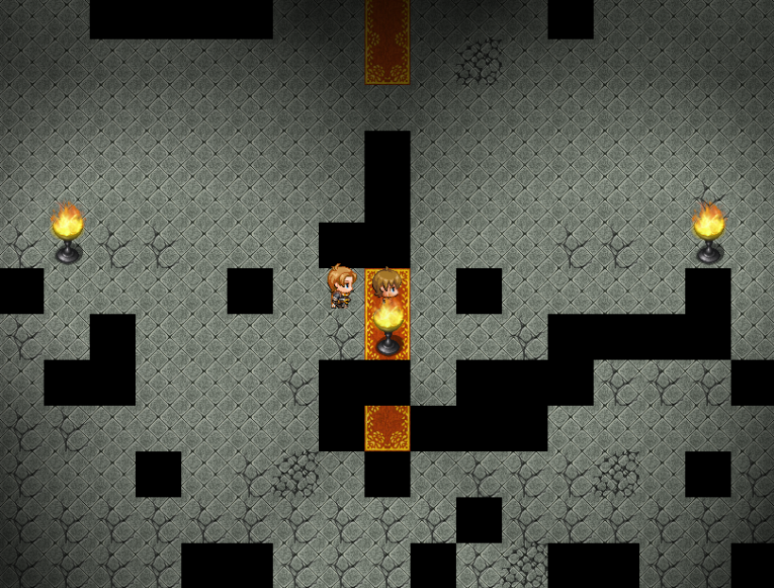

If you happen to fall into the crumbling holes, you will game over.

To get through the segment, follow this gif:

<https://gfycat.com/gifs/detail/PoshOrangeLeech>

After the Gauntlet, the game ends with a cutscene and credits will roll.